**DEDICATON**

This project is dedicated to God Almighty (The infinite intelligence), who in his infinite mercy gave us life and the enablement to design and construct this project. We also dedicate this project to the Department of Electrical and Electronics Engineering, Petroleum Training Institute, Effurun.

**ACKNOWLEDGEMENT**

We wish to express our sincere gratitude to God Almighty for the knowledge, strength, and mercies upon our life.

We are definitely indebted to the following people for their supports towards the success of this work; especially Engr. S. A. Orukele, Engr. A. E. Edicha who supervised this work. We appreciate their unrelenting effort in ensuring that we got vital result and utilized resourceful information.

Special thanks goes to our parents, brothers, and sisters who stood as a point of supports and assistance by assisting through finance, and their encouragement to enable this project a success.

Abstract

The objective of our project is to design, develop and monitor “Automatic bottle filling system and Level control process using PLC".This work provides lot of benefits like vocational and technical knowledge on process automation, low power consumption, lesser operational cost, less maintenance, fast response and many more. This project is based on Industrial automation and is a vast application used in many industries like oil and gas industries, milk industries, chemical, food, mineral water and many industrial manufacturers. A prototype with lamp as indicators has been developed to illustrate the project.

Filling is the task that is carried out by a machine and this process is widely used in many industries. In this project, the filling of the bottle is controlled by using a controller known as PLC which is also the heart of the entire system. For a real life project or construction the conveyor system, a dc motor has been selected for better performance and case of operation. For Level control process, Tank levels are monitored and controlled with much ease. This is common in many industries today ranging from milk industries, oil and gas or petroleum industries like the refinaries and depots, Sensors would be used to detect the level of liquid in a container in real life. In our project we have used less number of system hence the overall cost has been reduced to an extent. The project employs indicators or lamps to show all the process as expected to work. Ladder logic has been used for the programming of the PLC, which is the most widely used and accepted language for the programming of the PLC.The PLC used in this system is a Mitsubishi FX-01_20MR 001 which makes the system more flexible and easy to operate.

**CHAPTER ONE**

**1.0 INTRODUCTION**

**1.1 BACKGROUND OF THE STUDY**

In the past, humans were the main methods for controlling a system. However, the demand for more sophisticated, easy & effective means of control in process plants (ranging from large refineries & offshore facilities to small & medium scale manufacturing industries) has led to the rapid evolvement of control engineering over time.

Hence the birth of PLC has become a pivotal component in the Industries and educational Institutions, for engineering Operation Control due to its flexibility, higher reliability, communication possibilities, faster response, time & easy troubleshooting.

The PLC is a microprocessor base controller, it receives analogue & digital signal input from input components such as switches & sensors, and apply instructions stored in its programmable memory to control outputs to drive components such as motors, pneumatic device and status indicator. It implements functions such as Logic and sequence. The rapid pace of technological development with new models and innovation of PLC technology & its flexibility has encouraged its applications beyond industrial control spectrum. Therefore, the development of competence through training in the wiring, programming of PLC & its application becomes imperative for students and persons with interest in the field of industrial instrumentation & control. Nevertheless, some of the problems are that Industrial PLC is an expensive, prebuilt hardware kit. Also, the acquisition of programming software and its requisite programming competence is a challenge.

The programming language defined by IEC (International Electro-technical Commission) for PLC is the Ladder Logic (LL), Structure Text (ST), Function Block(FB), and Instruction List(IL). The PLC programming device can be handheld or the Personal computer. The Ladder Logic (LL) is the most used programming Language because it is simple to comprehend & Implement.

PLC’s were first developed for and by the automotive industry such as Mitsubishi. Today, PLC’s are manufactured around the world by hundreds of different manufacturers. PLC’s are no longer limited to just the automobile industry, They have evolved to become the standard for process control in any industry. For over 30 years since Mitsubishi Electric launched the first compact PLC on the European market, Mitsubishi has become the world market leader in this sector, with over 17 million of its compact controller installations to its credit, Many applications for which automation was once not even an option can now benefit from the many advantages of these controllers.

The Objective of this paper, is to present the Design & Construction of Mitshibushi FX-1s-20MR 001 PLC Training Kit basically centered on the Operation of PLC being the main component of the project.

This work is on a Mitsubishi FX-1s PLC training kit to simulate batch control of water. Mitsubishi Electric's controller line is one of the widest in the industry. Mitsubishi Is offering spans from Alpha Simple Application Controller with minimum as 6 I/O points, all the way to the high-end Q Series Automation Platform capable of running entire plants with thousands of I/O.

The Mitsubishi FX-1s-20MR 001 series logic module has 12 inputs and 8 relay outputs with a contact rating of 8A. This DIN rail mount logic module has a screw termination method. It has a large memory for the applications that require a large space. The logic module has a supply voltage that ranges between 85VAC and 264VAC.

**1.2 PROBLEM STATEMENT**

Setting up a programmable logic circuit whenever students want to carry out practical on the programmable controller Principles and Applications can be difficult and it involves much labor. Setting up a Mitsubishi FX-1s-20MR 001 Series programmable controller kit makes it easy in order to facilitate the practice of teaching. the principle and application of programmable logic controller (Mitsubishi models) (3) to the practical application of the theme set up experiments and training content. It can be as vocational and technical education production process automation.

**1.3 AIM AND OBJECTIVES OF THE STUDY**

This work is aimed at building a Mitsubishi FX-1s 20MR 001 training kit to simulate batch control of water. The objectives of the work are:

1. To build a Mitsubishi FX-1s series logic module has 12 inputs and 8 relay outputs
2. To have a wider knowledge about programmable logic module
3. To carry out the wiring of a FX-1s series logic module.

**1.4 BENEFITS OF THE STUDY**

This device has an operating temperature ranges between 0°C and 55°C, Program capacity is 4000 steps, extremely fast program execution, maximum flexibility and Ladder logic programming

**1.5 RESEARCH QUESTION**

1. How do you use a Mitsubishi PLC?
2. What is PLC Mitsubishi?
3. What software does Mitsubishi PLC use?

**1.6 APPLICATIONS OF THE STUDY**

The areas of application of this device are as below:

1. For vocational/educational purpose
2. Industrial applications
3. Automation industry

**1.7 SCOPE AND LIMITATION OF THE STUDY**

The scope of this work covers building a Mitsubishi FX-1s-20MR 001 series logic kit has 12 inputs and 8 relay outputs which offers wide range of controllers capable of satisfying the diversified application needs in various in vocational studies and industries. The device has Supply voltage of 264VAC, 12 input and 8 output, 4000 steps Program capacity, Ladder logic programming language, computer, HMI programming interface logic control module type and Output current of 500mA.

The only limitation of this device is that the teaching on Mitsubishi FX-1s-20MR 001 series logic requires lots of experience and knowledge.

**1.8 SIGNIFICANCE OF THE STUDY**

Education materials based on level of knowledge, from those who have never used PLC to those who wish to increase their mastery of PLC. It can be used as vocational and technical education production process automation.

Using this work will serve as the quickest way to master PLC and to understand the basic key points by practice.

**1.9 SYSTEM BLOCK DIAGRAM**

As stated earlier, the system has Supply voltage of 264 VAC, 12 input and 8 output. The overall block diagram of the system is as shown below:

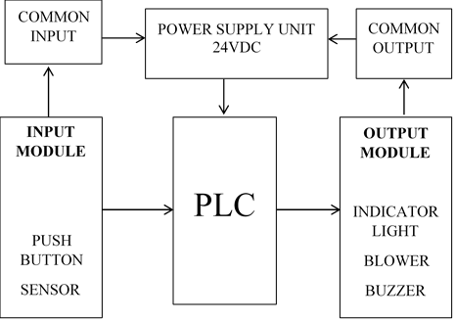

LOGIC   
CONTROLLER

PROGRAM

OUTPUT   
MODULES

INPUT   
MODULES

**CHAPTER TWO**

**2.0 LITERATURE REVIEW**

## 2.1 PROGRAMMABLE LOGIC CONTROLLER

PLC stands for “Programmable Logic Controller”. A PLC is a computer specially designed to operate reliably under harsh industrial environments – such as extreme temperatures, wet, dry, and/or dusty conditions. PLCs are used to automate industrial processes such as a manufacturing plant’s assembly line, an ore processing plant, or a wastewater treatment plant.

PLCs share many features of the personal computer you have at home. They both have a power supply, a CPU (Central Processing Unit), inputs and outputs (I/O), memory, and operating software (although it’s a different operating software).

The biggest differences are that a PLC can perform discrete and continuous functions that a PC cannot do, and a PLC is much better suited to rough industrial environments. A PLC can be thought of as a ‘ruggedized’ digital computer that manages the electromechanical processes of an industrial environment.

PLCs play a crucial role in the field of automation, using forming part of a larger SCADA system. A PLC can be programmed according to the operational requirement of the process. In the manufacturing industry, there will be a need for reprogramming due to the change in the nature of production. To overcome this difficulty, PLC-based [control systems](https://www.electrical4u.com/control-system-closed-loop-open-loop-control-system/) were introduced. We’ll first discuss PLC basics before looking at various applications of PLCs.

## 2.2 BASICS OF PROGRAMMABLE LOGIC CONTROLLER

PLCs were invented by Dick Morley in 1964. Since then PLC has revolutionized the industrial and manufacturing sectors. There is a wide range of PLC functions like timing, counting, calculating, comparing, and processing various analog signals. The main advantage of PLC over a “hard-wired” control system is that you can go back and change a PLC after you’ve programmed it, at little cost

## 2.3 PHYSICAL STRUCTURE OF PROGRAMMABLE LOGIC CONTROLLER

Programmable Logic Controllers continuously monitors the input values from various input sensing devices (e.g. accelerometer, weight scale, hardwired signals, etc.) and produces corresponding output depending on the nature of production and industry. A typical block diagram of PLC consists of five parts namely:

1. Rack or chassis
2. Power Supply Module
3. Central Processing Unit (CPU)
4. Input & Output Module
5. Communication Interface Module

### Rack or Chassis

In all PLC systems, the PLC rack or chassis forms the most important module and acts as a backbone to the system. PLCs are available in different shapes and sizes. When more complex control systems are involved, it requires larger PLC racks.

Small-sized PLC is equipped with a fixed I/O pin configuration. So, they have gone for modular type rack PLC, which accepts different types of I/O modules with sliding and fit in concept. All I/O modules will be residing inside this rack/chassis.

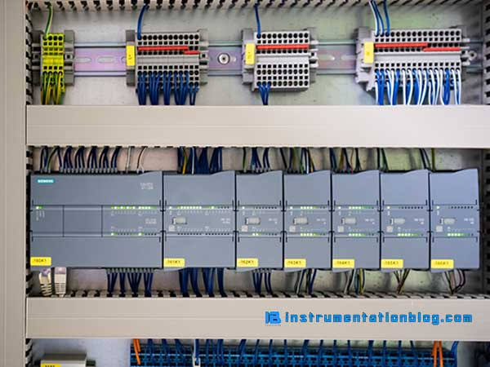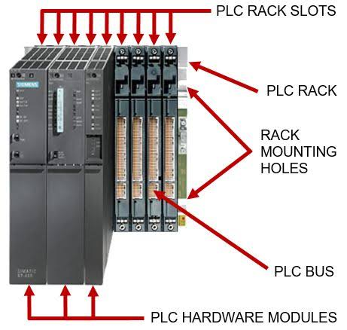

**PICTURES OF PLC RACK OR CHASSIS**

### Power Supply Module

This module is used to provide the required power to the whole PLC system. It converts the available AC power to DC power which is required by the CPU and I/O module. PLC generally works on a 24V DC supply. Few PLC uses an isolated power supply.

### CPU Module and Memory

CPU module has a central processor, ROM & RAM memory. ROM memory includes an operating system, drivers, and application programs. RAM memory is used to store programs and data. CPU is the brain of PLC with an [octal](https://www.electrical4u.com/binary-to-octal-and-octal-to-binary-conversion/) or hexagonal microprocessor.

Being a microprocessor-based CPU, it replaces timers, relays, and counters. Two types of processors as a single bit or word processor can be incorporated with a PLC. One bit processor is used to perform logic functions. Whereas word processors are used for processing text, numerical data, controlling, and recording data.

CPU reads the input data from sensors, processes it, and finally sends the command to controlling devices. DC power source, as mentioned in the previous discussion is required voltage signals. CPU also contains other electrical parts to connect cables used by other units.

### Input and Output Module

Have you ever thought about how to sense physical parameters like temperature, pressure, flow, etc? using PLC? Of course, PLC has an exclusive module for interfacing inputs and output, which is called an input & output module.

Input devices can be either start and stop pushbuttons, switches, etc and output devices can be an electric heater, valves, relays, etc. I/O module helps to interface input and output devices with a microprocessor.

## 2.4 TYPES OF PROGRAMMABLE LOGIC CONTROLLER

The two main types of PLC are fixed / compact PLC and modular PLC.

### Compact PLC

Within a single case, there would be many modules. It has a fixed number of I/O modules and external I/O cards. So, it does not have the capability to expand the modules. Every input and output would be decided by the manufacturer.

### Modular PLC

This type of PLC permits multiple expansion through “modules”, hence referred to as Modular PLC. I/O components can be increased. It is easier to use because each component is independent of each other.

PLC are divided into three types based on output namely Relay output, Transistor output, and Triac Output PLC. The relay output type is best suited for both AC and DC output devices. Transistor output type PLC uses switching operations and used inside microprocessors.

According to the physical size, a PLC is divided into Mini, Micro, and Nano PLC. Some of the manufacturers of PLCs include:

1. [Allen Bradley](https://ab.rockwellautomation.com/Programmable-Controllers/ControlLogix/5580-Controllers)
2. [ABB](https://new.abb.com/plc/programmable-logic-controllers-plcs)
3. [Siemens](https://new.siemens.com/global/en/products/automation/systems/industrial/plc.html)
4. [Mitsubishi PLC](https://www.mitsubishielectric.com/fa/products/cnt/plc/index.html)
5. [Hitachi PLC](https://www.hitachi-ies.co.jp/english/products/plc/index.htm)
6. [Delta PLC](https://www.deltaww.com/Products/CategoryListT1.aspx?CID=060301&PID=ALL&hl=en-US)
7. [General Electric (GE) PLC](http://www.geautomation.com/products/programmable-automation-controllers%EF%BB%BF)
8. [Honeywell PLC](https://www.honeywellprocess.com/en-US/explore/products/control-monitoring-and-safety-systems/scalable-control-solutions/Pages/masterlogic-plc.aspx)

## 2.5 PROGRAMMABLE LOGIC CONTROLLER PROGRAMMING

When using a PLC, it’s important to design and implement concepts depending on your particular use case. To do this we first need to know more about the specifics of PLC programming.

A PLC program consists of a set of instructions either in textual or graphical form, which represents the logic that governs the process the PLC is controlling. There are two main classifications of PLC programming languages, which are further divided into many sub-classified types.

1. **Textual Language**
   1. Instruction list
   2. Structured text
2. **Graphical Form**
   1. Ladder Diagrams (LD) (i.e. Ladder Logic)
   2. [Function Block Diagram](https://www.plcacademy.com/function-block-diagram-programming/) (FBD)
   3. Sequential Function Chart (SFC)

Although all of these PLC programming languages can be used to program a PLC, graphical languages (like ladder logic) are typically preferred to textual languages (like [structured text programming](https://www.plcacademy.com/structured-text-tutorial/)).

### Ladder Logic

[Ladder logic](https://www.plcacademy.com/ladder-logic-tutorial/) is the simplest form of PLC programming. Ladder logic has evolved into a [programming language](https://en.wikipedia.org/wiki/Programming_language) that represents a program by a graphical diagram based on the [circuit diagrams](https://en.wikipedia.org/wiki/Circuit_diagram) of [relay logic](https://en.wikipedia.org/wiki/Relay_logic) hardware. Ladder logic is used to develop software for [programmable logic controllers](https://en.wikipedia.org/wiki/Programmable_logic_controller) (PLCs) used in industrial control applications. The name is based on the observation that programs in this language resemble [ladders](https://en.wikipedia.org/wiki/Ladder), with two vertical rails and a series of horizontal rungs between themIt is also known as “relay logic”. The relay contacts used in relay controlled systems are represented using ladder logic (Edward, 2019). The below figure shows a simple example of a ladder diagram.

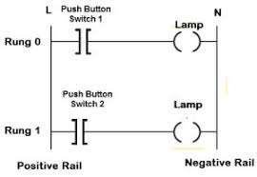

PLC Ladder Logic

In the above-mentioned example, two pushbuttons are used to control the same lamp load. When any one of the switches is closed, the lamp will glow.

The two horizontal lines are called rungs and the two vertical lines are called rails. Every rung forms the electrical connectivity between Positive rail (P) and Negative rail (N). This allows the [current](https://www.electrical4u.com/electric-current-and-theory-of-electricity/) to flow between input and output devices.

## 2.6 HISTORICAL BACKGROUND OF PLCS

Many early PLCs were not capable of graphical representation of the logic, and so it was instead represented as a series of logical expressions in a Boolean format (akin to [Boolean algebra](https://www.electrical4u.com/boolean-algebra-theorems-and-laws-of-boolean-algebra/)).

As programming terminals evolved, it became more common for ladder logic to be used, because it was a familiar format used for electro-mechanical control panels. More modern formats, such as state logic and Function Block diagrams exist, but they are still not as popular as ladder logic (Walker, 2012).

A possible reason for this is that programmers prefer the more visual appeal of ladder logic over structured text programming.

Until approximately the mid-1990s, PLCs were programmed using proprietary programming panels or special-purpose programming terminals, which often had dedicated function keys representing the various logical elements of PLC programs (Walker, 2012).

Some proprietary programming terminals displayed the elements of PLC programs as graphic symbols, but plain [ASCII code](https://www.electrical4u.com/alphanumeric-codes-ascii-code-ebcdic-code-unicode/) representations of contacts, coils, and wires were common.

**2.7 MITSUBISHI PLC**

Mitsubishi Electric Corporation (abbreviated as MELCO), established on 15 January 1921, is a Japanese [multinational](https://en.wikipedia.org/wiki/Multinational_corporation) electronics and electrical equipment manufacturing company headquartered in [Tokyo](https://en.wikipedia.org/wiki/Tokyo), [Japan](https://en.wikipedia.org/wiki/Japan). It is one of the core companies of [Mitsubishi](https://en.wikipedia.org/wiki/Mitsubishi). The products from MELCO include [elevators](https://en.wikipedia.org/wiki/Elevator) and [escalators](https://en.wikipedia.org/wiki/Escalator), high-end [home appliances](https://en.wikipedia.org/wiki/Home_appliance), [air conditioning](https://en.wikipedia.org/wiki/Air_conditioning), [factory automation systems](https://en.wikipedia.org/wiki/Factory_automation), train systems, [electric motors](https://en.wikipedia.org/wiki/Electric_motor), [pumps](https://en.wikipedia.org/wiki/Pump), [semiconductors](https://en.wikipedia.org/wiki/Semiconductors), [digital signage](https://en.wikipedia.org/wiki/Digital_signage), and [satellites](https://en.wikipedia.org/wiki/Satellite) (Pollack, 2020).

The MELSEC-F series PLC incorporates power supply, CPU, and I/Os into a single compact unit. Meets the needs of a variety of user applications with options for I/O, analog, positioning, and open network expansion

**PICTURE OF MITSUBISHI PLC**

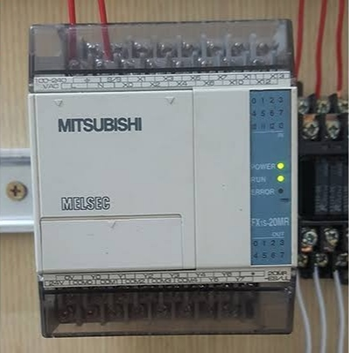

.

**2.8 REVIEW OF RELATED STUDIES**

Although researchers have proposed and reported several PLC trainers that discuss the hardware connection of the input/output components neither is the basic PLC (automatic operation) nor PLC component symbols with description discussed. This page discusses the related works based on the logic controllers.

**Bhise et al (2015)** proposed an embedded PLC for teaching students. Authors combined LabVIEW software and the AVR Microcontroller with the VB modules to achieve the embedded PLC built bottle filling plant for it application. The programming language used for the embedded PLC is the FB. Although the embedded PLC setup is flexible, relatively easy and affordable to teach the basic principle for PLCs, they did not present or discuss FB program for the bottle filling application. Also, survey report of their application shows moderate performance in stability and reliability.

**Mahadi et al (2015)** proposed a PLC Trainer Kit Simulator Automation Lab at the Polytechnic of Sultan Abdul Halim Mu’adzam Shah (POLIMAS). The training kit comprises the Omron PLC CPU unit with 12 inputs and 8 outputs control. Input and output devices are bank of switches and light indicators respectively. They used CX- Programmer for CP1E version 1.0 to program the PLC using ladder diagram and instruction list PLC programming languages. The fabrication of a multiple input/output (I/O) PLC module for educational purpose to enhance the learner’s theoretical comprehension and hands-on skill especially for programming, cabling, circuit design and problem solving according to Ibrahim et al (2015). Their module consists of I/O devices such as push buttons (normally open), DC motor (24V), DC relay (24V), DC solenoid piston cylinder (24V) and DC light (24V) capable of interfacing with PLC controller produced by Matsushita, Omron, Siemens. Survey report from the trainees show that 95.70 % attest to the enhancement in their theoretical comprehension and hands-on skill competence in their learning process.

**Sukir et al (2019)** proposed a PLC Based Electrical Machine Trainer Kit developed for Electrical Engineering Practices in the Department of Electrical Engineering Education at Faculty of Engineering, Universitas Negeri Yogyakarta. Their approach is research and development with reference to the ADDIE model from RobertMaribe Branch. The installed PLC is Zelio SR2.201FU and the console dimension is 44.1 cm ×100 cm and 92.7 cm ×100 cm with a front tilt angle of 80 °. Authors examined the performance of trainer kit on 8 practical experiment; rotation control of DC motors; rotation control of three phase induction motor; rotation control of one phase induction motor; starting DC motor; starting 3 phase induction motor using auto-transformer; dynamic DC motor braking; DC motor braking by plugging; and braking 3- phase induction motor by DC injection. Result show the trainer kit has a good performance, indicated by the electrical components and the practical work description can function appropriately as planned. They used the Delta DVP14SS2 PLC, WPLSoft software and switches as inputs and pilot lamps as outputs. Instructors trained student on cabling and programming of PLC with hands-on training on Traffic light automation application. Authors carried out pre and post training evaluation for trainee and result show significant improvement of about 45.8% in the trainees’ capacity to wire and program a PLC for automation control.

**Samanol et al (2014)** analyze "Development of pneumatic trainer kits for polytechnic students," which produces pneumatic trainer kits for learning the basics of pneumatics for students of the Department of Engineering, Seberang Perai Polytechnic, Malaysia. These studies differ from this particular research, in terms of trainer kit products and use.

Related to research on Programmable Logic Controllers (PLC), **Akparibo John (2016)** conducted a study entitled "Development of a programmable logic controller training platform for the industrial control of processes." The research obtained an interactive, cheaper and more portable PLC trainer kit for industrial process control simulations. The PLC Trainer kit makes it easy for students of the Department of Electrical and Electronic Engineering in FUTO, Nigeria to install and program all types of inputs and outputs according to their choice. The application of the PLC trainer kit in learning improves student achievement compared to before using the PLC trainer kit.

**The Department of Mechatronics Engineering, College of Engineering (COLENG), Federal University of Agriculture, Abeokuta (FUNAAB)** has taken quantum leap towards the University’s quest for global visibility with the assemblage and development of Programmable Logic Controller (PLC) Based Training Equipment code named FUNAAB-TK-0121 and FUNAAB-TK-0221.According to Dr. Oyelami, the project was funded and supervised by Prof. Lawrence Kehinde in the Department while the assemblage of the equipment was carried out by a recent graduate of the univesrsity, Mr. Habeeb Mustapha and a final year student, Mr. Daniel Adeleke.He disclosed that the PLC-based equipment “has key comparative advantages over imported ones because students are given the opportunity of seeing, touching and modifying all equipment components, rather than using them as black boxes”.

**CIRCUIT DIAGRAM OF MITSUBISHI FX-1s-20MR 001** **PLC TO SIMULATE LEVEL AND BATCH CONTROL OF BOTTLE WATER**

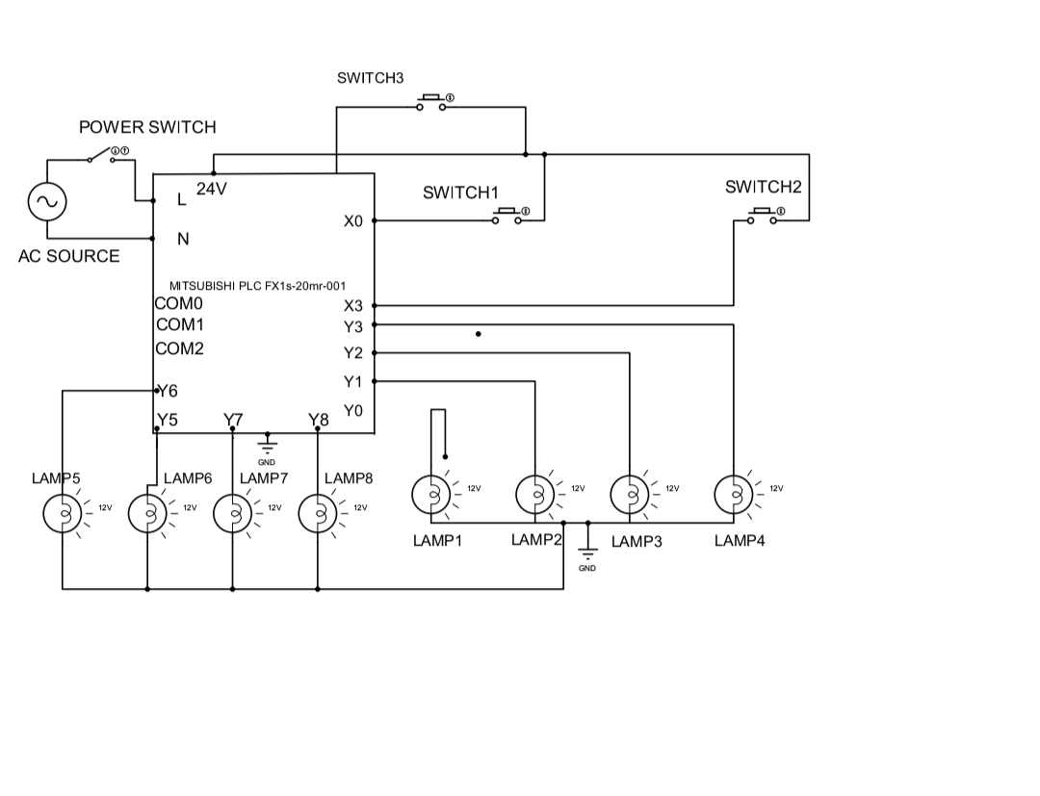

**CHAPTER THREE**

**3.0 METHOD OF ANALYSIS**

With the need for a design of a batch control process, we shall in this chapter analyze the components which will be required for this design and construction and also the specifications which they shall need to meet for the success of this training kit.

With the constraint of this project lying on its requirements for a fair knowledge of software engineering especially on the area of programming. A grounded knowledge of batch control alongside A fair knowledge of panel wiring is also important together with Digital and analogue input/output and their conversions.

It is also necessary in the design of this project that certain requirements are taken into consideration, for instance:

i. Safety.

ii. Production/Running cost.

iii. Interfaces to a PC and possibly HMIs.

iv. Compatibility with common industrial electrical components.

In this project work, we shall be designing and eventually constructing a PLC training Kit using the Mitsubishi FX2N-32MT which would be used in the Instrumentation Laboratory of the Petroleum Training institute for the purpose of simulating Batch control process.

To achieve success of this design work, it is extremely important that we consider each component in depth especially with regards to its power requirements and its compatibility with other components which we shall be using in the construction of this project work. We shall also be paying keen attention to safety and cost in our assessment of the components and their eventual selection.

**3.1 DESIGN SPECIFIFCTIONS**

The design of this PLC based level control system has the following components:

1. The power supply unit.
2. The controller unit.
3. The conductors.
4. The indicator Lamps.
5. The switches.
6. The housing structure.
7. The programming/Simulation.

**3.2 DESIGN CONSIDERATION OF EACH COMPONENT**

Considering the vast range of components available in the market with varying specifications. It has become of extreme importance we pay keen attention to ensure that components selection is done with not just safety and power requirements but also its compatibility with every other component we shall be using. With that in mind and with the knowledge of our desired output which is a training kit, we shall move ahead to detail the steps taken in the selection of our various components.

**3.3 TOTAL CURRENT REQUIREMENT**

It is of great importance that we make the selection of our components with keen attention to their power requirements. We shall have to understand the individual current requirement for the components and this shall be applied to determine our overall current requirement. Having this knowledge will be very helpful also in the selection of our power supply unit.

Current rating of the conductors: 300mA x 24 = 7200mA

Current rating of the controller: 500mA

Current rating of Led’s: 1.5mA x 12 = 18mA

Total current: 7.2+0.5+1.8 = 9.5A

**3.4 THE POWER SUPPLY UNIT**

The power supply was chosen to meet the requirement of supplying current to the entire system as no component of the system will be powered externally. The following specifications were used in the selection of the power supply:

Number of power supply: 1

Nominal input voltage: 220/240 VAC

Frequency: 50Hz

Output voltage: 110/220VAC

Factors considered in selecting the above output voltage: include the PLC voltage requirements (220VAC) and the indicator voltage (110VAC). Since all voltages are equal, we choose the 110/220VAC output.

Output Power: 24 watts

The output power was selected based on the power requirements of the various components used. The calculation for the output power can be found under each component.

**3.5 THE CONTROLLER UNIT**

For the purpose of this project, we shall be using the MITSUBISHI FX2N-32MT PLC as our controller. This component will be responsible for the control of all the components of the project which ranges from turning ON/OFF the process pump to control level to activating the LAL and LAH in case of system failures.

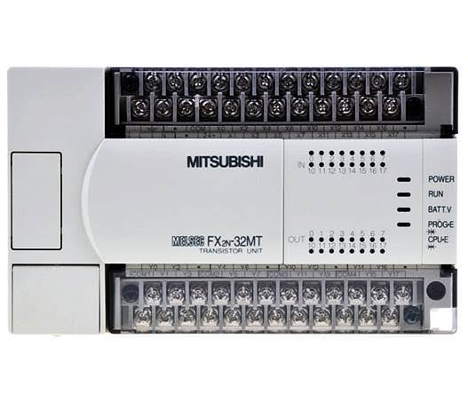

Figure 3.1 Pictorial diagram of the PLC

The PLC has the following specifications:

Number of PLC: 1

Dimension (W x H x D) mm: 150 x 90 x 87

Number of inputs: 24

Number of outputs: 16(Transistor)

Output type: Transistor

PLC Input voltage : 100 - 240 VAC

PLC Programming Interface: Computer

Operating current: 500mA

Input frequency: 50Hz

Power requirements: P=I x V

V=240V

I=500Ma/1000=0.5A

P=0.5x240

P=120watts

Connection cable: 2*1.5mm2

Programming Language: Ladder Logic

External memory module: Not Available

Program Capacity: 8000 Steps

**3.6 THE CONDUCTORS**

It is of extreme importance that the proper conductor sizing is selected. To achieve this, we would have to pay attention to the load requirement of the entire system.

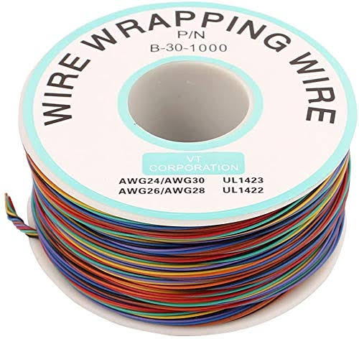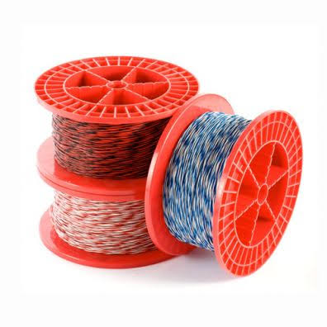

Figure 3.2 Diagram of the conductors (jumper wires)

The conductors shall be selected with respect to the following specifications.

Number of cables: 24

Voltage Requirement: 110/220VAC

Current Requirement: 2000watts

Cable Lengths: 2mm2

**3.7 THE INDICATOR LAMPS**

These components shall be used in the training kit to indicate the process going on in the level control process. It shall be designed to indicate the moment the system is turned ON, the level of process fluid in the process tank, the process of the controller (PLC) in the control of level in the process tank. There shall also be designated Lamps to indicate faults such as overflow in the process tank.

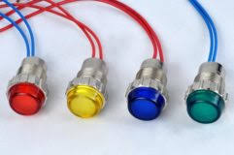

Figure 3.3 Diagram of the indicator lamps

The selection of the Lamps shall be based on the following specification:

Voltage Requirement: 110/220 VAC

Current Requirement: 20ma

Dimensions: 3.46 × 2.72 × 1.02 inches

Mounting hole size: 8mm

Color: Red, Yellow and Green.

**3.8 THE SWITCHES**

For the purpose of this project work, we shall be considering the Push button switches. These are switches which are pushed to either activate or deactivate them. As they are going to be very important component of the training kit and shall serve to complete/connect or disconnect a circuit to start or stop a process. With the wide range of options in the market, it is very important we pay special attention in their selection.

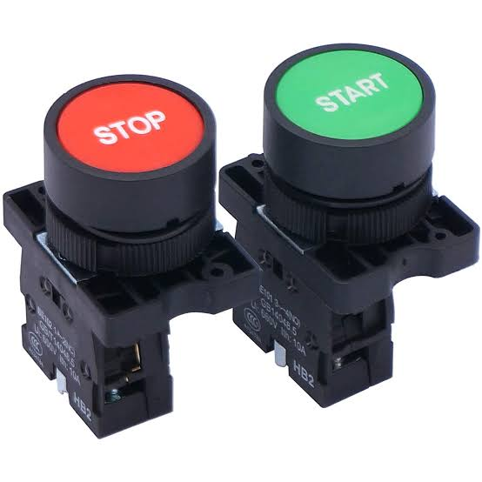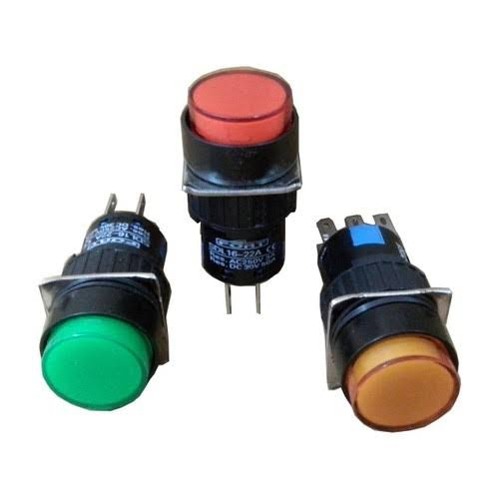

Figure 3.4 Diagram of the switches.

The following criteria shall be considered in the selection of our switches.

Voltage Requirement: 110VAC

Current Requirement: 1000mA

Number of Pins: 2

Colour of switches: Red and Black

Model of switches: Normally Open

Depth of switches: 16mm

Length of switches: 25mm

**3.9 THE HOUSING STRUCTURE**

This is the part of the Training Kit that shall serve to house (contain) the entire components being used in the construction of this project work. It is of utmost importance that we consider cost, mobility and material strength in selecting the material for our housing structure. The following requirements were considered in the selection of our housing structure:

1. Cost of the material to be used.
2. Strength of the material.
3. Durability of the material.
4. Ease of fabrication of the material.

Having considered the above points, we have decided to select wood as our most desired housing material. We shall be fabricating in the best possible way to economize space and also neatly contain all the components of the training kit.

The sizing of the structure shall be designed to meet the below specification:

Width:

Height:

Area:

Length:

**3.10 THE SOFTWARE DESIGN**

In the software design of our batch control process, we shall be using a personal computer and Ladder Logic programming software (GX Developer) to write a ladder logic program which would be used to simulate a batch control process. This part is made up of two major structures which must be treated properly to ensure the success of this project work. They are:

#### ALGORITHM GENERATION

An algorithm is a statement of the procedure adopted in solving a problem. The supposed sequence of the system operation is stated below:

1. Powering ON of the training Kit.
2. Powering ON/Booting of the Personal Computer.
3. Starting up of the GX Developer and running of the program.
4. Simulation of a batch Control process.
5. End of the process.
6. **FLOW CHART**

This is basically a chart that uses graphical representation to describe the proposed sequence of operation of this training kit.

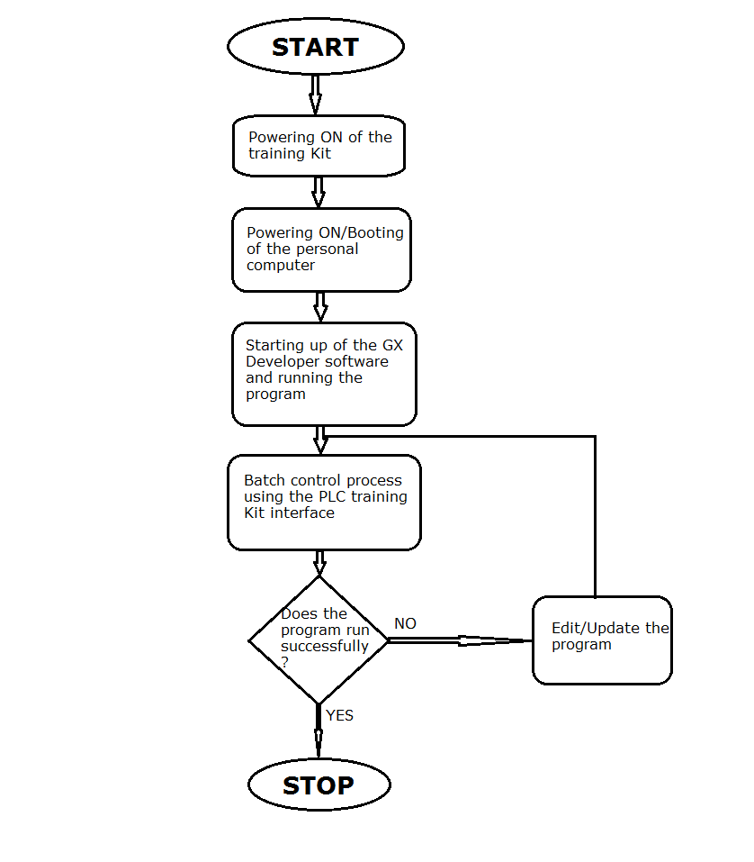

Figure 3.5 Diagram of the entire system’s flow chart

**3.11 THE PROGRAMMING/SIMULATION**

In this part of the project work, we shall be using the Ladder Logic programming Language to write a program which would be applied to our training kit to simulate a batch control process. It is important to note that in the simulation of this project work, different programs can be written to achieve endless results but we shall be focusing on batch control using the Mitsubishi FX2N-32MT. This process can be further divided into three basic steps which are:

1. **THE PROGRAMMING**

This is the point where we shall be using the ladder logic program to create a program that would simulate a real life experience of a batch control process. It shall involve the conveyor, the automatic discharge valve, the process tank, the timer, the controller.

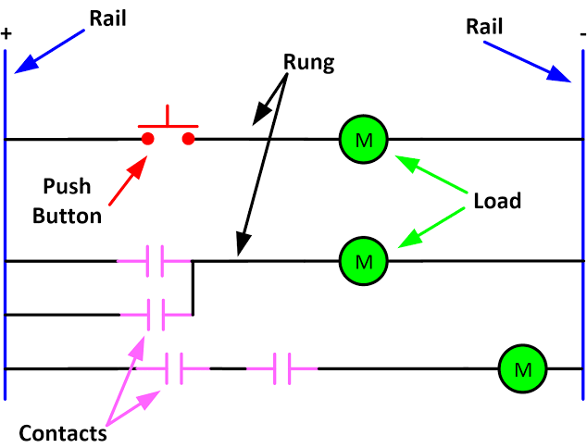

Figure 3.6 Sample Diagram of a Ladder Logic Program

1. **THE IMPLIMENTATION STAGE**

This involves the use of a personal computer and GX developer to test run the already written program. The system to be used shall be selected with respect to the GX developer requirements and its compatibility with the MITSUBISHI FX2N-32MT. After writing the program on our developer interface, we shall run it on the system to ensure that the process works seamlessly and efficiently before moving forward to implement it on the training kit.

1. **THE SIMULATION STAGE**

Here we are going to upload the program to the PLC and we shall run it using the training kit. It shall be ensured that everything else in regards to the connection of the training kit has been completed before attempting to run the program. After the program has been uploaded to the PLC, we shall start using the Training Kit interface to control a batch process. When a start switch is pressed, the led indicator comes on to indicate the start of the process. Subsequently, every action carried out on the training kit shall be indicated using the Led’s attached for this purpose.

**3.12 USING THE TRAINING KIT FOR BATCH CONTROL PROCESS**

For the purpose of this project work, we shall be programming this training Kit for a batch control process. The components of the batch control process which shall be considered in the programming shall include:

* + 1. **THE CONVEYOR**

For the purpose of this construction, we shall be considering the belt conveyor considering its easy of design, construction, installation and also maintenance.

A belt conveyor is a carrying medium that uses a continuous belt to transport products in a straight line or through changes in height or direction. A conveyor belt uses two end-pulleys that loop over a long section of thick, which is a durable material.

As the motor in the pulley moves at the same speed and rotates in the same direction, the belt moves between the two. If the items are heavy or bulky or if the conveyor belt is moving them over long distances, rollers may be installed on the sides of the conveyor belt for support.

A belt conveyor is the cheapest conveyor, simple in construction, and easy to use. It is used to move bulk materials like water bottles, cartons, coal, sand, etc.

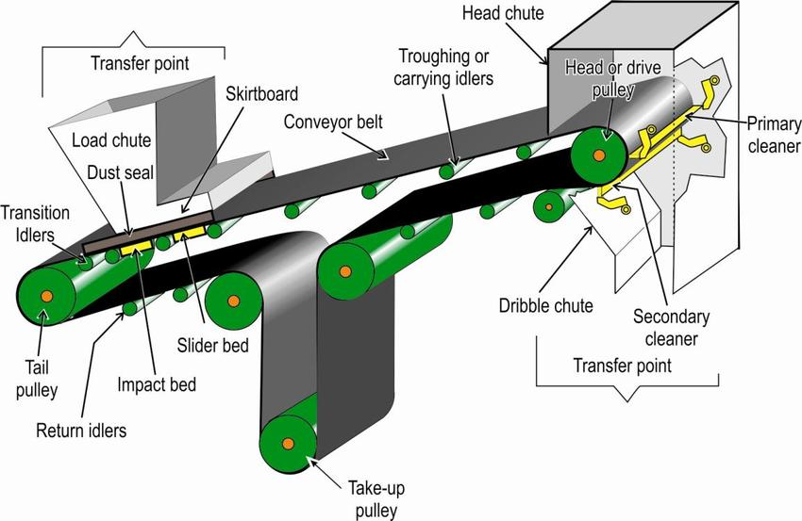

Figure 3.7: Diagram of a complete belt conveyor

The major parts of the Conveyor include:

1. **The Belt**

This is going to be the main point of attention in our project work. In as much as the belt type conveyor has other important parts, the Belt has happened to be the reason for its name. This component is responsible for basically taking our product or material from one point to another in the conveyor system and in this case is the largest part of our conveyor.

It is mostly made of metallic or aluminum shits depending on the prescribed load and is usually placed on supports which are popularly called belt supports. In longer conveyor distances, more number of belt supports are introduced and eventually rollers which shall enable the ease of movement of the belt to reduce the load on the pulley systems.

### Belt Support

Belt support is a component of a conveyor system that allows the belt to move smoothly without any restrictions.

If the support unit is not stable, the belt fails if there is a heavy object on top of it, and this causes the belt to not move as smoothly or as fast as it should. The belt remains tight and moves efficiently by the use of support units.

### Pulley System

It is the external component that is used to control the speed of the belt. Each unit has two pulleys, one is operated by electricity, and another one is idle. And modern conveyor systems may have extra rotors on the entire frame.

1. **The Drive Unit**

The drive unit allows the conveyor system to move or operate. It has a counter bearing which effectively keeps the moving components. It also provides for moving the belt in the opposite direction and managing the repeated adjustments in the direction for some systems.

## 3.12.2 Advantages of Conveyor System

Below is some of the almost inexhaustible list of the advantages of a bet conveyor in a process plant:

1. A conveyor system is one of the cheapest process to move material over long distances.
2. The height of the conveyor may change and the material can be seen on the belt of the conveyor while conveying.
3. Belt conveyors may have designed with metal separators and it has trippers to unload the belt at almost any location.
4. Belt conveyors can turn at one end to move the discharge along an arc. Also, Sidewalls can be added to the belt to prevent product leakage.
5. In conveyors, weigh belt sections can also be added for continuous product weighing.

**3.12.3** **OTHER COMPONENTS OF OUR BATCH PROCESS**

1. **The process tank**

The process tank shall serve for the storage of our material which shall be used in the filling of our bottles. The process tank shall be calibrated using a 5 point calibration system (0%, 25%, 50%, 75%, and 100%). Our automatic discharge valve shall be connected at the 25% calibration point and a manual valve shall be connected at the 75% point for the refilling of the process tank.

1. **The Timer**

Timer in processes and Ladder logic program are used to automatically start, stop or switch a process. In this simulation, we shall be using our timer to start and stop our conveyor and also to start and stop our discharge valve.

1. **Automatic Discharge Valve**

We shall be using a solenoid valve for the purpose of automatic discharge. In our program, it shall be connected to the timer to regulate its operation. It shall be represented with an indicator lamp on the training kit to show when it is open and when it is closed.

1. **The controller**

The controller in our program whose function shall be executed by the PLC shall serve to control the conveyor and the discharge valve to control the entire Batch process.

**3.13 MECHANISM OF OPERATION OF THE PROGRAM**

When the system is initialized (Start of the Kit and the running of the program from the GX Developer), the PLC shall initialize and then starts the timer for the conveyor. The timer for the conveyor shall run for 5 seconds and moves the bottle under the discharge valve. An indicator lamp for the conveyor shall shine for 5 seconds to show this. After 5 seconds, the conveyor stop and the discharge valve is turned ON. The discharge valve is kept open for 10 seconds to imitate the filling of the process tank. An indicator lamp is used to show this on the training kit.

After the discharge pump runs for 10 seconds, the timer stops the discharge pump and starts the conveyor again. The process continuous until the system is stopped. Indicator lamps shall be used to show the entire process on the training kit simultaneously with the ladder program being executed.

**3.14 ADVANTAGES OF THE PROJECT**

Considering the rapid changing face of industrialization and process control and its continuous dependence on programmable controllers. The importance/advantages of this project have thus become inexhaustible. Some of these advantages include:

1. It shall serve as a training Kit to bring field experience of level process control to the students.
2. The project shall require little to no maintenance.
3. With respect to the intended construction material, the project shall be lasting a long period of time.
4. It shall be of great assistance in the teaching/Lecturing of not just automation and process control but also in the area of Ladder Logic programming Language.
5. It shall serve in the education about Programmable Logic Controllers.
6. It shall provide a good source of reference to future project works in the field of not just Automation and control Engineering but Electrical Engineering in general.

**3.15 CONSTRAINTS OF THE PROJECT**

In the design of this project work, we have encountered some challenges and it is important we document such challenges as it shall also be important for the future projects in this field. These constraints are:

1. The PLC is a complex instrument and requires a high level of technicality in its wiring and programming.
2. The cost of acquiring the PLC is on the high side and as such eliminates the idea of redundancy.
3. The selection and fabrication of the material for the frame work and also the arrangement of the circuit to achieve the success of the training kit shall require a high level of technicality.
4. Considering the unavailability of an HMI for the PLC, it shall require a personal computer to display the program being run on the PLC alongside the indicators on the training Kit and this shall reduce the portability of the entire project work.

**CHAPTER FOUR**

**4.0 CONSTRUCTION**

In this chapter, we shall be treating the construction of this project work. We shall be covering the details involved in the construction of the training kit starting from the measurements to the commissioning of the training kit. Alongside this, we shall also be treating the precautions taken in the construction of the training kit.

**4.1 MATERIALS, TOOLS AND EQUIPMENTS USED**

Here we shall be listing the various tools and equipment which shall be used in this project work construction.

**4.2 MATERIALS**

i. PLC

ii. Switches

iii. Lamps

iv. Casing

v. power cord

**4.3 TOOLS**

i. Drilling machine

ii. Handsaw

iii. Tape

iv. Multimeter

v. Screw drivers

vi. Plier

**4.4 STEPS IN THE CONSTRUCTION OF THE PLC TRAINING KIT**

In this section, we shall be treating the various steps taken in the construction of the training kit.

1. Construction of the casing
2. Installation of the components
3. Preparation of the PC
4. Wiring of the components
5. Commissioning of the Training Kit

**4.5 PREPARATION OF THE PC**

At this stage, having purchased our Personal computer (the computer) following the consideration in chapter 3. The following steps were observed in preparing the PC for the control job:

1. The PC was powered ON
2. The PC was properly booted
3. The GX Developer software was installed on the PC using the software disk and following the installation procedure.
4. The program was run on the PC
5. A test ladder program was written and stimulated on the GX Developer.

**LADDER LOGIC PROGRAMMING**

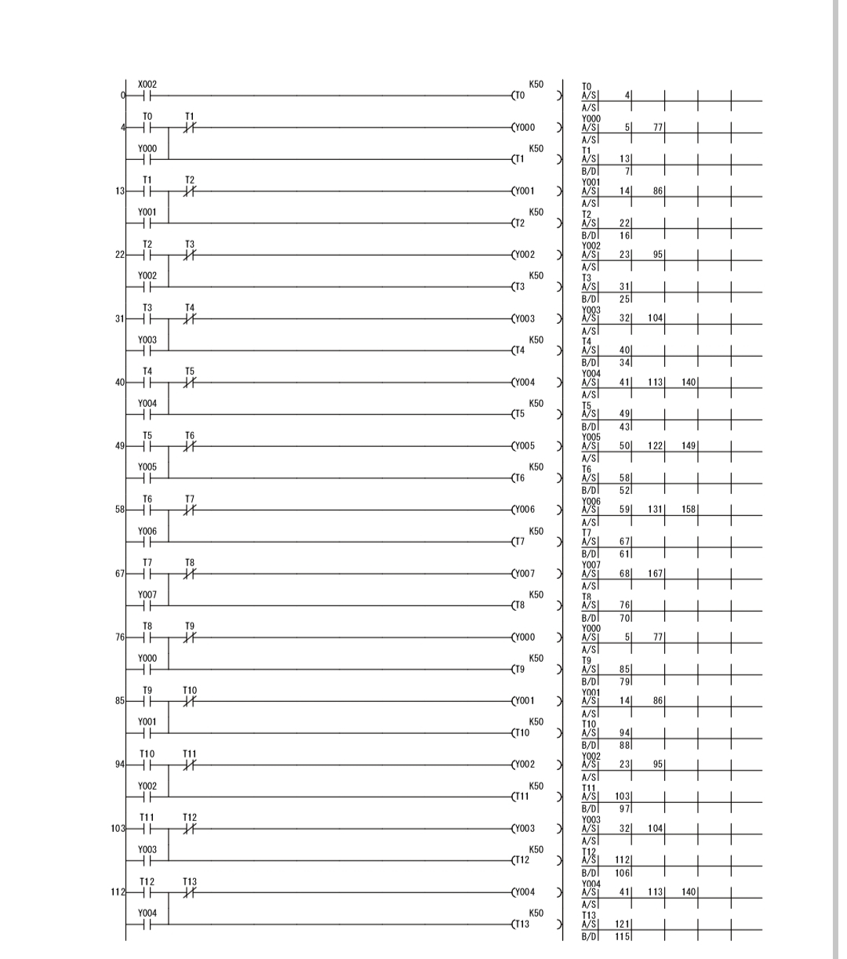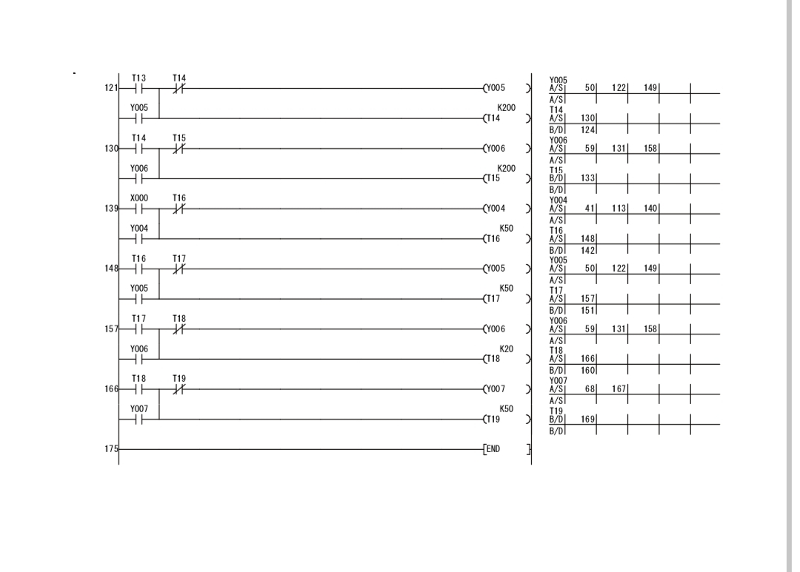

**4.6 INSTALLATION OF THE COMPONENTS**

At this stage, we shall be treating the steps taken in arranging and placing the components in the housing structure/casing:

1. The PLC was placed inside the casing and marked out using a pencil.
2. The terminals were placed in the casing in their desired arrangement and marked using a pencil.
3. The lamps were also arranged in the casing and marked using a pencil.
4. We checked to ensure the casing could close effectively with the current arrangement made.
5. We glued the PLC to the casing using gum.
6. We allowed some moments for the PLC to stick firmly to the casing.
7. We drilled a hole in the casing and installed the lamps and the terminals.

**4.7 CONSTRUCTION OF THE CASING**

In this section, we shall be treating the various steps taken in the construction of our casing after having selected our material following steps as listed in chapter 3. They are:

1. The material was measured using a tape and a meter rule.
2. The required shapes and sizes were marked using a pencil.
3. The marked areas were cut out using saw and cutter
4. The cut material was joined using gum and screw.
5. Excessive material was removed using and file and sand papering tool.
6. The Casing was polished using a ash color to give it a smooth feel and nice touch while also protecting it from mechanical damage and increasing insulation.
7. The handle was installed using screw drivers and screws.
8. The height of the casing is 20cm
9. The weight of the casing is 30cm

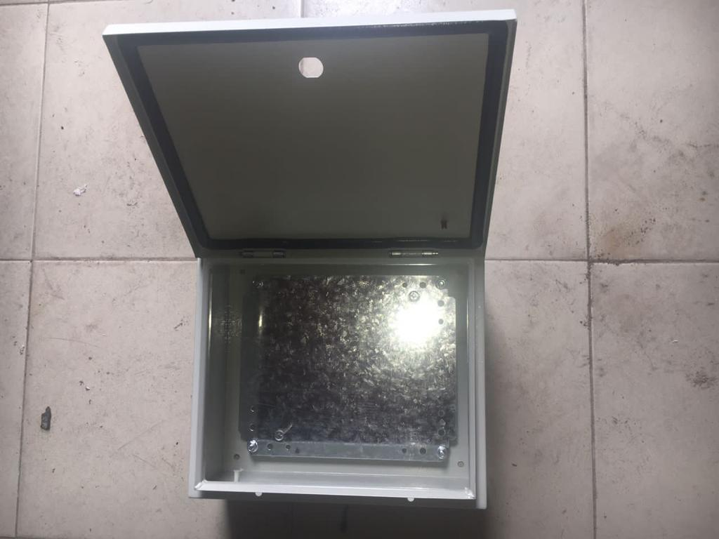

**4.8 WIRING THE COMPONENTS**

In this stage, we made use of the jumper wires which was selected in chapter 3 to carry out our wiring operation. The wires were cut using pliers and soldered at the required points. To ensure clean soldering, excessive leads were removed from the soldered points.

**4.9 COMMISSIONING OF THE TRAINING KIT**

The following steps were taken in the commissioning of the training kit:

1. The power cables was connected
2. The network cable was connected
3. The PC was turned ON.
4. The programs were run on the training kit and its response was observed.
5. The training kit was properly shut down.

## 4.10 TESTS AND RESULTS

The following tests were carried out and the following results were obtained:

**Table 4.1: Test and Result**

|  |  |  |  |  |
| --- | --- | --- | --- | --- |
| **Test** | **Aim** | **Equipment**  **used** | **Result** | **Conclusion** |
| Firmness test. | To ensure all components were tightly installed in the casing | Slight pulling | All the components were firmly installed as none pulled | All components were properly installed |
| Open Circuit test | To ensure there is no open circuit on the wiring done from one component to another | Digital Multimeter | All the test points read R>1Ω | There is no open circuit in the connection therefore the connection was properly done |
| Insulation test | To ensure there is no leakage current from any of the components to the casing of the training kit | Digital Multimeter | There was no continuity at all the test point which means there is no leakage current | There is no leakage current therefore insulation is perfect. |
| Short Circuit Test | To ensure there is no short circuit on the wiring done from one component to another. | Digital Multimeter | All the test points read R>1Ω. | There is no short circuit in the connection therefore the connection was properly done |
| Operation test | To ensure the system was working efficiently | The system was powered ON and the programs were run and were observed on the training kit. | Operated as required | System is in good operating condition. |

**4.11 PICTURES OF THE TRAINING KIT**

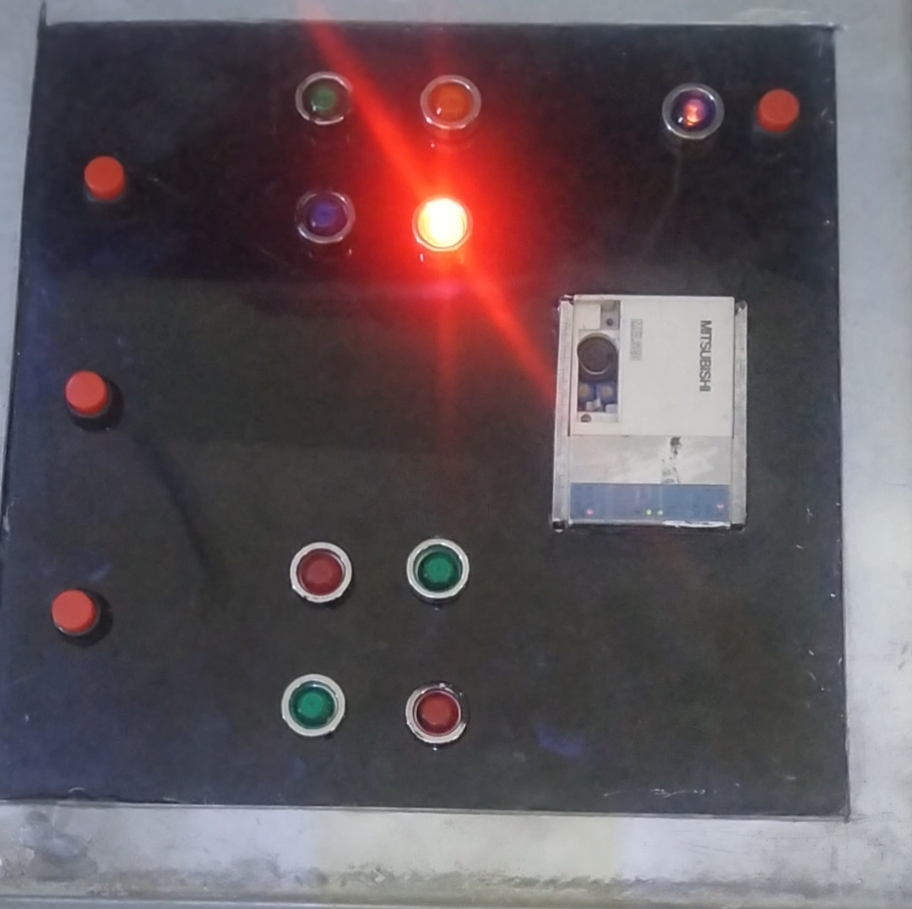

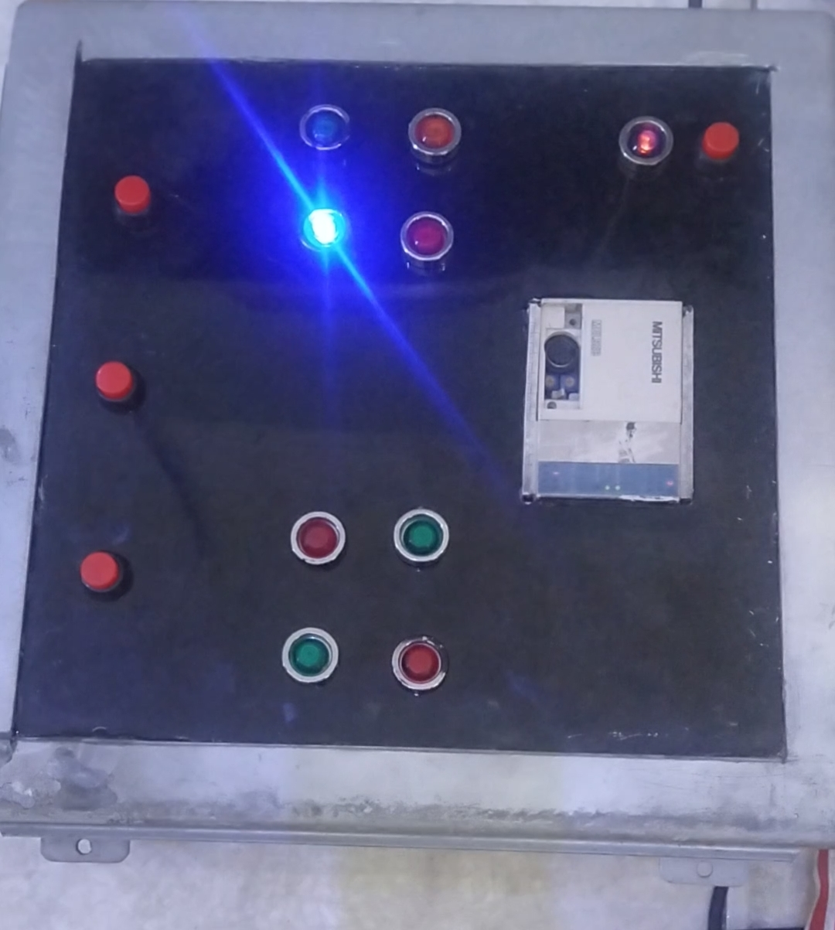

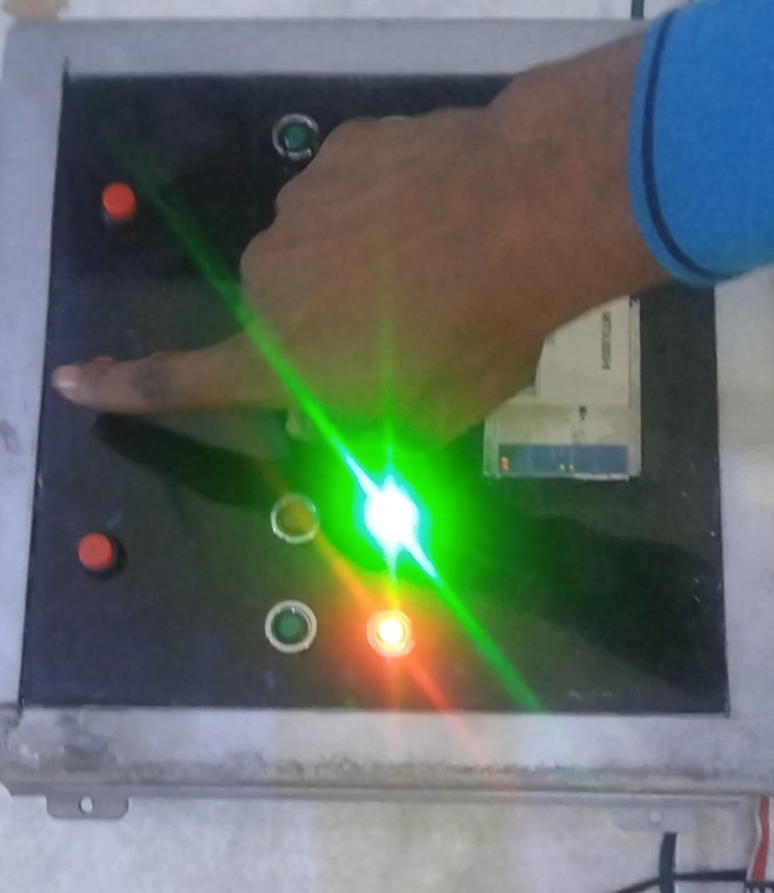

**Table 4.2: Bill of engineering material**

|  |  |  |  |  |
| --- | --- | --- | --- | --- |
| **S/N** | **DESCRIPTION OF ITEM** | **QTY** | **UNIT PRICE (N)** | **TOTAL PRICE**  **(N)** |
| 1 | MITSUBISHI FX-1s-20MR 001 | 1 | 150,000.00 | 150,000.00 |
| 2 | Switch | 3 | 150.00 | 450.00 |
| 3 | Indicator Lamp | 8 | 200.00 | 16000.00 |
| 4 | Voltage Regulator | 1 | 500.00 | 500.00 |
| 5 | Casing | 1 | 15,000.00 | 15,000.00 |
| 6 | Power supply (power pack) | 1 | 8,000.00 | 8,000.00 |
|  | **TOTAL** |  | **174,000.00** | **190,000.00** |

**4.12 PRECAUTIONS FOR USING THE TRAINING KIT**

i. Ensure to study and understand every equipments manual before commencing its use.

ii. Ensure to use the training kit in Safe and well lit environments

iii. Be cautious of hazards possible in the use of the training kit.

iv. Ensure adequate care is applied in the use of the equipment to avoid damaging it.

v. Ensure use of proper power source in operating the training kit.

vi. Keep the equipment in clean area and away from moisture atmosphere to prevent insulation problem.

vii. Do not take any maintenance work or operation without the presence of the Lab Technician.

viii. When maintaining, turn off the main power to prevent electric shock.

**4.13 PRECAUTIONS TAKEN IN THE CONSTRUCTION OF THE TRAINING KIT**

i. We ensured accurate measurements were taken before cutting the material

ii. We ensured to work only in safe environment while taking safety rules into great consideration.

iii. We ensure appropriate care was taken in cutting and in joining the casing material to reduce wastage of material, obtain better look and improve efficiency.

iv. We ensured proper connection of the components.

1. We applied great care in sizing the components in its casing to ensure the components fit and space isn’t wasted.
2. We ensured to follow the operational manual of all the equipment
3. We ensured to seek technical advice and assistance whenever necessary all through the construction process.
4. We ensure to consider reliability and safety of the users and environment in the construction of the training kit.

**CHAPTER FIVE**

**5.0 CONCLUSION AND RECOMMENDATION**

In this chapter, we shall be focused on the conclusion of the PLC training kit and possible recommendations for future works in this field. We shall be taking a brief look on the entire project work before concluding this work.

**5.1 CONCLUSION**

Just as the desire to be an Engineer and solve problems has been born in us over years so has the need for a better industrial control process, a better teaching tool been needed in the petroleum training institute. This project work has been targeted in solving the problem of better practical teaching aid in the Electrical Engineering Department of the Petroleum training Institute Effurun, Delta State.

Starting from the chapter one, we took out time to clearly declare what this project shall be all about alongside the scope of the construction of this training kit. After we were done with this, we went further to in the chapter two of this work take a look at related works that has been done in this field trying to understand their scopes and their limitations to further know the best needs to focus on in the construction of this training kit so it would not just be a repetition of previous engineering works but instead an improvement to the area of control engineering.

Having understood other jobs in this area, we went ahead to in our chapter three design our desired project work. In this chapter we had made a selection of all the components that shall be used in the construction of this work and also the reasons for these selections was properly done. We went ahead to in the chapter 3 of this work describe in as much details as possible the steps followed in the construction of this training kit along side with the various tests that have been carried out to ensure the reliability of this construction and its efficiency. We also ensure to list out precautions which shall be vital for the operation of this component.

Finally, considering the work flow from the chapter one to this current stage, we shall conveniently declare the successfully conclusion of this training kit.

**5.2 RECOMMENDATION**

As we have listed certain limitations which shall affect this project training kit in our chapter one, we shall in this section go ahead to make certain recommendations for any future works in this field.

Considering the cost limitations, we have substituted certain materials and tools in the construction of this training kit ranging from the casing material to the Programmable logic controller. We shall as such recommend the provision of funds for future projects to ensure better design and outlook for future works.

Also, we shall recommend that future works be targeted at ensuring complete use of all ports of the PLC to make for maximal use of the PLC and also experiment on the operational capacities of the PLC.

Finally, we recommend the testing of additional programs on the training kit and also on the design and development of future works in this field to make provisions for the multi-programming training kits.

# REFERENCE

Engr. Abubakar. E. Edicha, Engr. D.M Enweliku, (2013); “Programmable logic controller for Automation Industry.” Published and Printed in Nigeria by Ben-Ame Corporate Ventures, 1st edition.

Muffili Mahadi, Muhajir Rahim, and Abdul Majid, (August 2015); “PLC Trainer Kit Simulator”

Okoji Matthew et al, (2021); “Design and Construction of PLC Training Kit Using Allen-Bradly”

Igwe. A. Daniel et al, (2021); “Design and Construction of Siemens Logo PLC Based Liquid Level Control Process”

Micro Automation “Mitsubishi Melsec FX2N 32MT”. [Online]. Available: <https://microautomation-bd.com/mitsubishi-melsec-fx2n-32mt/>

Pollack, Andrew (2020). ["BUSINESS TECHNOLOGY; Fastest, Maybe Smoothest, Trip Up"](https://www.nytimes.com/1993/09/22/business/business-technology-fastest-maybe-smoothest-trip-up.html). The New York Times. [ISSN](https://en.wikipedia.org/wiki/ISSN_(identifier)) [0362-4331](https://www.worldcat.org/issn/0362-4331).

Adi Permana. (2019). Memahami Berbagai Perubahan di Era Revolusi Industri 4.0. Taken on February 20, 2020.

Akparibo, A.R., Appiah, A., & Antwi, O.F. (2016). Development of a Programmable Logic Controller Training Platform for the Industrial Control of Processes. American Scientific Research Journal for Engineering, Technology, and Sciences (ASRJETS**,** (2016), Volume 15, No 1, pp 186-196.

Asuncion & Ronaldo. (2019). Low Cost 2 Station Industrial Automation Trainer. Available at SSRN: [https://ssrn.com/abstract=3471693](https://ssrn.com/abstract%3D3471693) or [http://dx.doi.org/10.2139/ssrn.3471693](https://dx.doi.org/10.2139/ssrn.3471693)

Branch, R.M. (2009). Instruction design: the ADDIE approach. New York: Springer Science + Business Media.

Georg Rauter,et.al. (2019). When a robot teaches humans: Automated feedback selection accelerates motor learning. Science Robotics. Vol. 4, Issue 27, 20 Feb 2019.

Gill, K.J.S., Kumar, R., & Kumar, S. (2015). Designing and fabrication of electro-pneumatic trainer kit. International Conference of Advance Research and Innovation (ICARI-2015), India, p.59-66.

Heilo Altin & Margus Pedate. (2013). Learning Aproaches to Applying to Robotics in Science Education. Journal of Baltic Science Education. Vol 12, No.3. 2013. ISSN 1648-3898.

Hong, et.al. (2013). Development of an Educational Robotic Training Kit. Advanced Science Letters. Volume 19, Number 11, November 2013, pp. 3304-3306(3).

Mamodiya, U., & Priyanka. (2014). Review in Industrial Automation. IOSR Journal of Electrical and Electronics Engineering (IOSR-JEEE)e-ISSN: 2278-1676,p-ISSN: 2320-3331, Volume 9, Issue 3 Ver. IV(May –Jun. 2014), PP 33-38[www.iosrjournals.org.](http://www.iosrjournals.org/)

Maria Maximova & YoungHwan Kim. (2016). Research Trend Analysis on the Usage of Robotic in Education. Asia-Pasific Collaborative Education Journal. Vol 12. No. 1. 2016. pp. 45-60.

[Michael](https://www.allaboutcircuits.com/author/stephen-st.-michael), S.St.(2018). What Is a PLC? An Introduction to Programmable Logic Controllers. https://[www.allaboutcircuits.com/technical-articles/what-is-a-plc](http://www.allaboutcircuits.com/technical-articles/what-is-a-plc)-introduction-to-programmable-logic-controllers/

Rauner, F., et. al. (2011). Handbook of technical and vocational education and training research. Bremen: Springer Science Business Media.

Samanol, S.B., Hamid, S.B.A, & Ramli, M.N.B. (2014). Development of Pneumatic Trainer Kit For Polytechnic Student. Journal of Mechanical Manufacturing (J-Mfac). Vol. I. 2014. p. 178-183.

Sean, C. (2015). BeRobot-The Robotic Scientific Education Development Kits.

Lovotics, an open access journal, Volume 3, Issue 1, 2015. p. 1-4. ISSN: 2090-9888.

Universitas Negeri Yogyakarta. (2016). Rencana Induk Penelitian 2016-2010.

Yogyakarta: LPPM Universitas Negeri Yogyakarta.

M. Barrett, "The Design of a Portable Programmable Logic Controller (PLC) Training System for Use Outside of the Automation Laboratory" in 2008 International Symposium for Engineering Education, Dublin City University, Ireland, 2008.

K. Bhise, S. S. Amte, "Embedded PLC Trainer Kit with Industry Application" Int. J. Eng. Sci. Innovative Tech (IJESIT), **4**(3), 1-9, 2015.

C. D. Johnson, Process Control Instrumentation Technology (8th ed.), Upper Saddle River, New Jersey, Prentice Hall, 2006.

W. Bolton, Programmable Logic Controllers, (4th ed.), UK, ELSEVIER, 2006.

D. H. Gawali, V. K. Sharma, "FPGA Based Micro-PLC design Approach” Advances in Computing, Control, and Telecommunication Technologies" in 2009 International Conference on Communication, Computing and Electronics Systems, 2009.https://doi.org/10.1109/ACT.2009.167

M. Mahadi, N. A. Mohd Amin, M. Ab-Rahim, M. S. Abdul Majid, "PLC Trainer Kit Simulator: An Improvement for Automation Study in Polimas” Appl. Mechanics and Mater., **786**, 367-371, 2015.

B. Ibrahim, A. A. Ahmad, T. Saharuddin, "Multiple Input/Outputs Programmable Logic Controller (PLC) Module for Educational Applications" in 2015 Innovation & Commercialization of Medical Electronic Technology Conference (ICMET), Shah Ala, Malaysia, 2015.

S. Sukir, A. S. J. Wardhana, "Performance of A Programmable Logic Controller Based Electrical Machine Trainer Kit" J. Phys.: Conf. Ser., **1413** (2019) 012011, IOP Publishing, 2019.

R. Awingot, A. Albert, F. A. Oliver, "Development of a Programmable Logic Controller Training Platform for the Industrial Control of Processes" Am. Sci. Res. J. Eng., Tech. Sci. (ASRJETS), 186-196, 2016.

C. Sărăcin, L. G. Deaconu, "Educational Platform Dedicated to the Study of Programmable Logic Controllers and the Human Machine Interface" in 2019 The 11th International Symposium on Advanced Topics in Electrical Engineering, Bucharest, Romania, 2019.

E. S. Maarif, S. Suhartinah, "Compact Portable Industrial Automation Kit for Vocational School and Industrial Training" in 2017 International Symposium on Materials and Electrical Engineering (ISMEE), 2017.

Kim, Y. S., Lee’ J. O. and Park C.W. “A hybrid learning system proposal for PLC Wiring Training Using AR”, e-Learning in Industrial Electronics (ICELIE), 2011 5th IEEE International Conference, pp. 90 – 94, 2011.

Lee, J. O. and Kim, Y. S “An AR-based Wiring Practice for PLC Training”, Journal of International Council on Electrical Engineering, Vol. 1, Issue 4, pp. 425 – 429, 2011.

Kim, Y. S. and Kim, H. ‘Design of a New Virtual Interaction Based PLC Training Using Virtual Sensors and Actuators: System and its Application’, International Journal of Distributed Sensor Networks, Vol. 2013, pp. 1 – 8, 2013.

Barrett, M. “The Design of a Portable Programmable Logic Controller (PLC) Training System for Use Outside of the Automation Laboratory”, International Symposium for Engineering Education, Dublin City University, Ireland, pp. 1 – 5, 2008.

Guo, L. and Pecen, R. “Design Projects in a Programmable Logic Controller PLC) Course in Electrical Engineering Technology”, American Society for Engineering Education, pp. 1 – 10, 2008.

Petruzella, F. D. Programmable Logic Controllers, McGraw-Hill New York, USA, 4th edition, 414 pp, 2011.

Chitra, S. and Raghavan, V. “Conveyor Control Using Programmable Logic Controller”, International Journal of Advancements in Research and Technology, Vol. 3, Issue 8, pp. 1 – 7, 2014.

<https://www.electrical4u.com/programmable-logic-controllers/>

<https://www.automationcontrols.com.pk/product/mitsubishi-fx3g-40mr-es-plc-logic-module-24-input-16-output-without-display/>

<https://www.allied-automation.com/wp-content/uploads/2015/02/MITSUBISHI_FX3G-Users-Manual-%E2%80%93-Hardware-Edition.pdf>